First Terminal Examination:-2082

Name: Class : UKG
Subject: My World Date :
1.Draw your picture and write about yourself. (12)
- My name is ……………………………
- I am ……………. years old.
- I am a …………... (boy/ girl)
- I study in class ………………...
- My fevourite colour is ……………
- I like to eat ……………
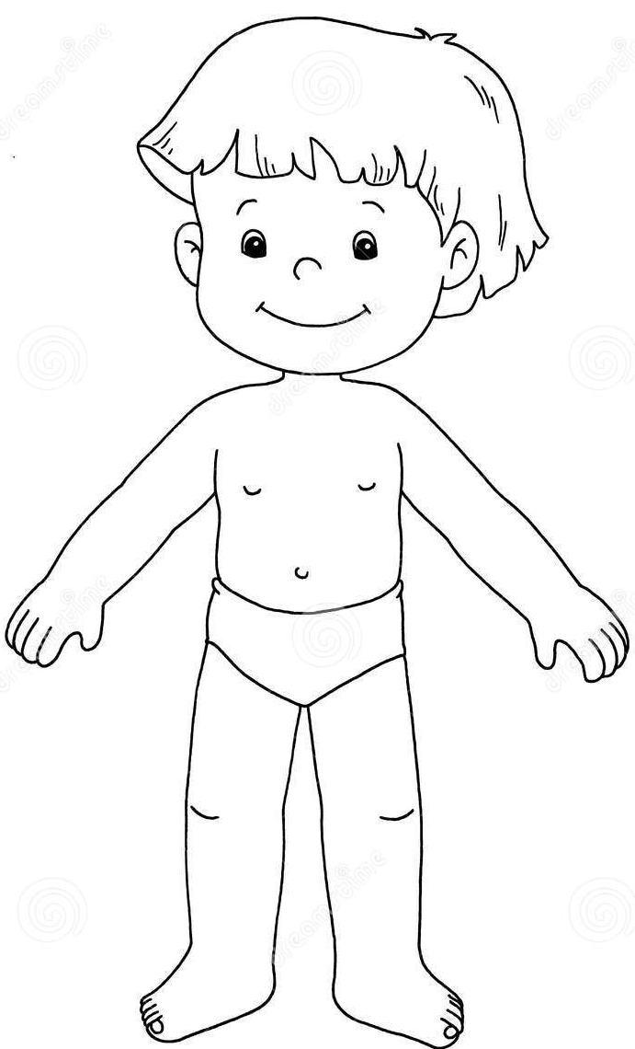
- Write down the name of body parts. (16)

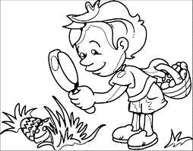
- Complete the given sentences. (10)
We see with our ………………..
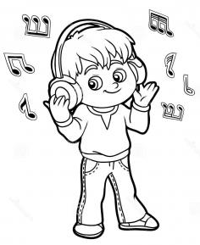
We hear with our ………………..
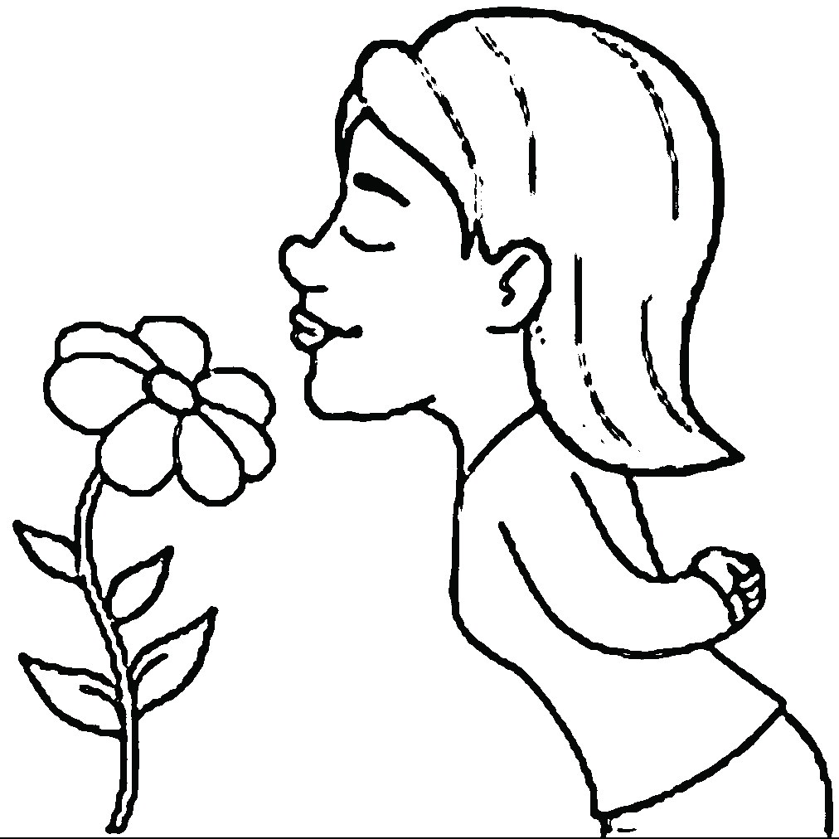
We smell with our …………………
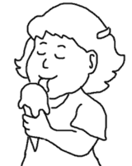
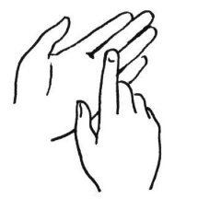
We taste with our ………………….

We feel with our …………………

4. Write the name of pictures and colour. (12)

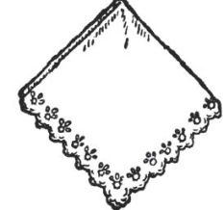
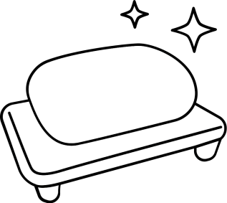

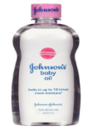
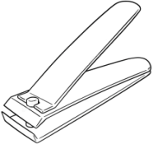


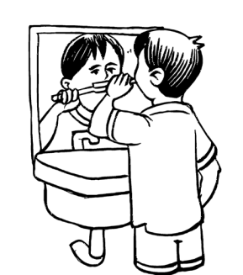
- See the pictures and write ‘Good’ for good habits and ‘Bad’ for habits. (8)
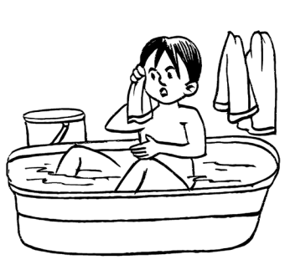
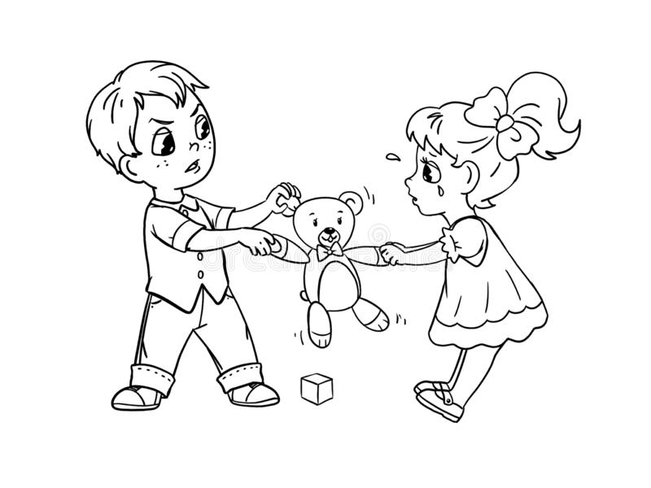
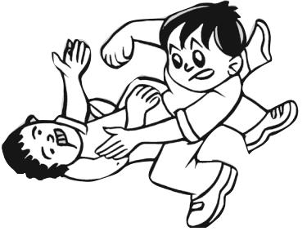

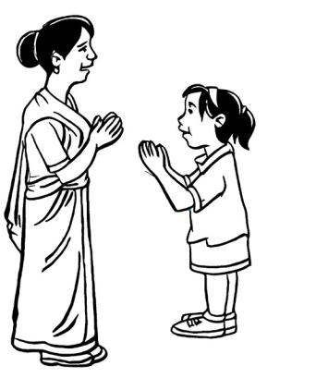
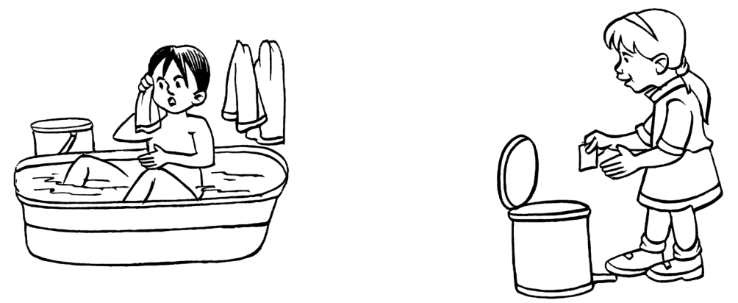
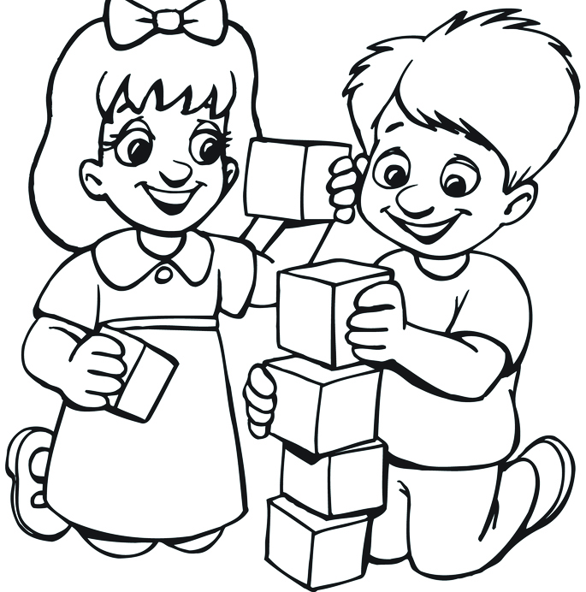
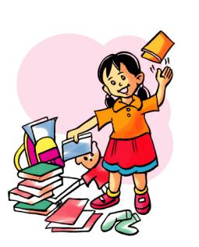

- How would you feel? Draw your emotion. (6)

Eating fruits Falling down

Getting chocolate Getting scolded

- Circle the family words and write. (10)
m | o | t | h | e | r | b
f | v | s | l | u | t | r
a | y | i | o | n | v | o
t | z | s | o | c | v | t
h | q | t | o | l | m | h
e | f | e | z | e | m | e
r | q | r | s | o | n | r

mother

- Tick the correct answer. (5)
- Where do we keep our books. ( chair , table )
- Where do you keep shoes? (doormat , shoes rack)
- Where do we keep toys? ( toy box , chair )
- Where do we keep clothes? ( cupboard , shoes rack )
- Where do we keep pencils? ( toy box , pencil box)
- Choos the picture of spring season and colour. (6)
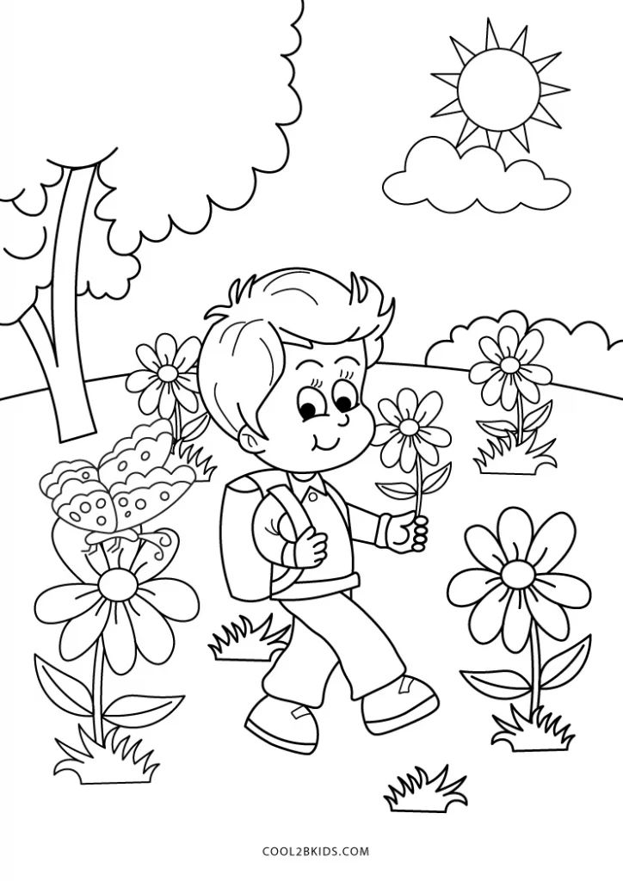
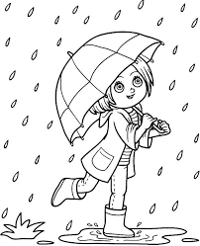

10. Anwer the following questions. (15)
- What is your name?
…………………………………………………………………
- How many family members are there in your family?
…………………………………………………………………
- Do you love your family?
…………………………………………………………………
- Draw your family picture.

