k|yd q}dfl;s k/LIff
gfd M sIff M o'=s]=hL=
ljifo M g]kfnL ldlt M

!_ …sÚ b]lv …1Ú ;Dd n]Vg'xf];\ M -!^_

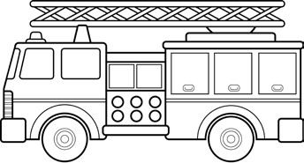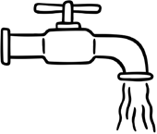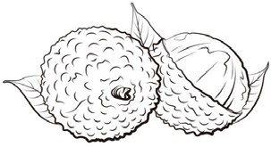
@_ zAb / lrqsf] hf]8f ldnfpg'xf];\ M -!)_

sfutL
wf/f
lstfa
lnrL
bdsn

#_ b'O{ ;fpF cIf/n] ag]sf zAbx¿ n]Vg'xf];\ / s'g} b'O{sf] lrq agfpg'xf];\ M -!)_

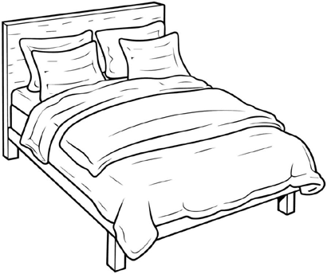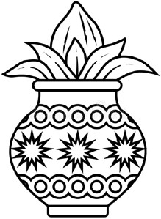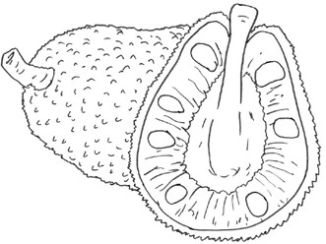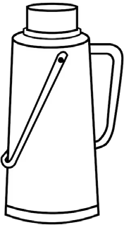
$_ lrqsf] gfd n]Vg'xf];\ M -!@_

%_ afx|v/L n]Vg'xf];\ M -!)_

s
sM
r
rM

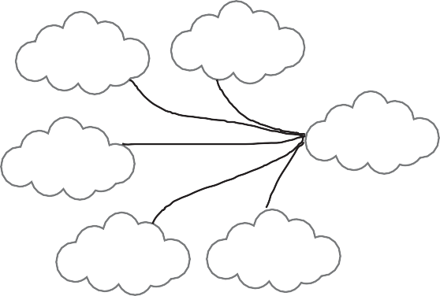
df hf
nf
cf
df
tf
^_ ;lx dfqf lrGx / zAbsf] hf]8f ldnfpg'xf];\ M -$_

f l L

rs6L
dfnf
n;'g
lrq

&_ zAb agfpg'xf];\ M -!)_

*_ tnsf] dfqf nfu]sf zAbx¿ n]Vg'xf];\ M -!@_

x|:j Osf/ -l_ | bL3{ O{sf/ -L_


(_ jfSo agfpg'xf];\ M -!@_

cfdf – 5ftf – lstfa –
;fyL –

!)_ lrqdf /ª eg'{xf];\ / gfd n]Vg'xf];\ M -$_

