k|yd q}dfl;s k/LIff
gfd M sIff M g;{/L
ljifo M g]kfnL ldlt M
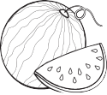
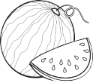

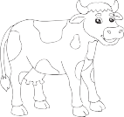

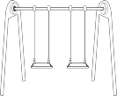
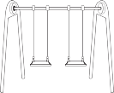
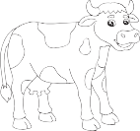

!_ p:t} lrqsf] hf]8f ldnfpg'xf];\ M -!)_
@_ p:t} cIf/sf] hf]8f ldnfpg'xf];\ M -!)_




#_ …sÚ cIf/df uf]nf] 3]/f nufpg'xf];\ M -!)_
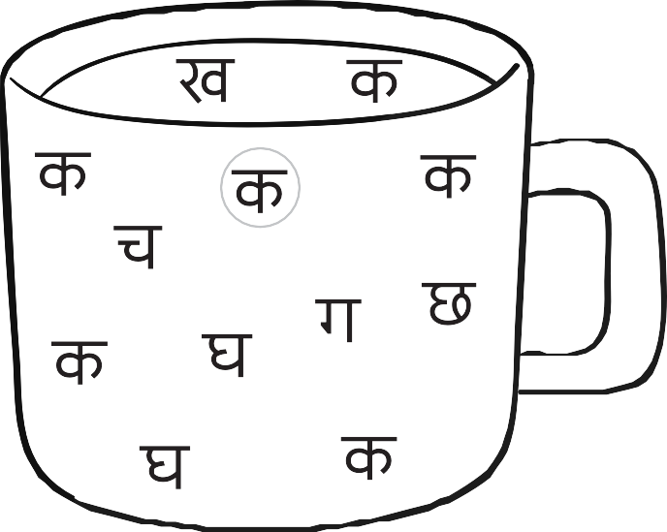

$_ cIf/sf] ldNbf] lrqdf /ª nufpg'xf];\ M -!%_


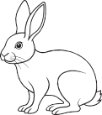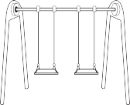
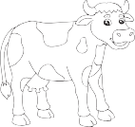

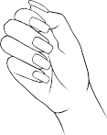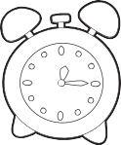


%_ ldNg] cIf/df uf]nf] 3]/f nufpg'xf];\ M -!@_
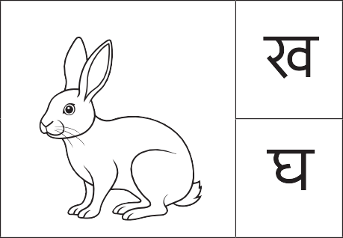
^_ …rÚ cIf/df uf]nf] 3]/f nufpg'xf];\ M -!)_

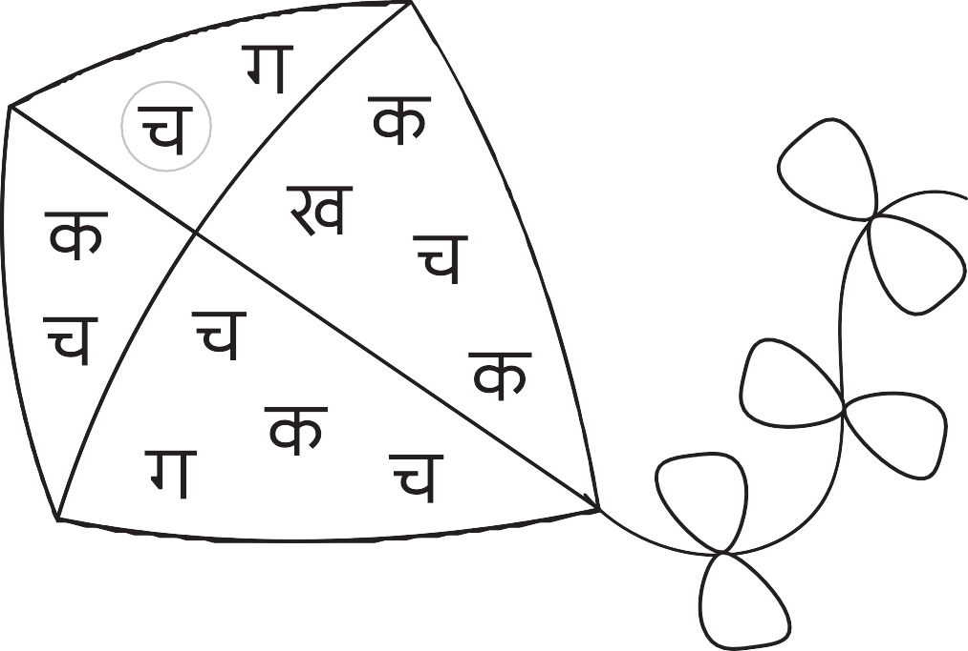


&_ gldNg] cIf/df /ª nufpg'xf];\ M -!)_



*_ …sÚ b]lv …ªÚ ;Dd n]Vg'xf];\ M -!%_
(_ yf]Knf hf]8]/ lrqdf /ª eg'{xf];\ M -*_

s 5
v r
u 3 ª

