k|yd q}dfl;s k/LIff
gfd M sIff M Pn\=s]=hL=
ljifo M g]kfnL ldlt M

!_ lrqx]/L klxnf] cIf/ n]Vg'xf];\ / /ª eg'{xf];\ M -^_

@_ tn lbOPsf cIf/x¿nfO{ qmda4 hf]8\g'xf];\ M -$_

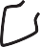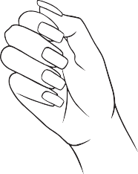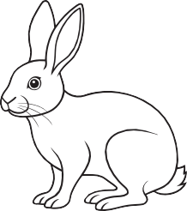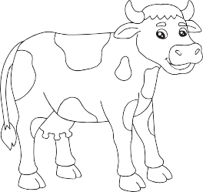5 em 6

h ` 7
- 0f

- t


#_ vfnL 7fpFdf ldNbf] cIf/ eg'{xf];\ M -!)_
y a

$_ lrq x]/L ldNbf] cIf/df uf]nf] 3]/f nufpg'xf];\ M -^_
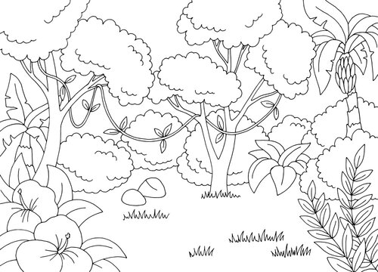 | j
 | z

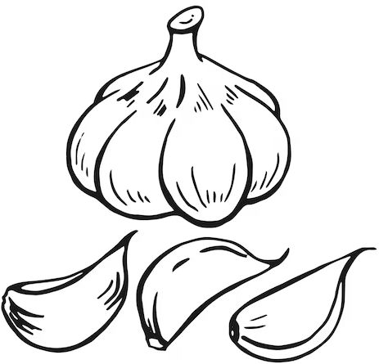 | /
 | n

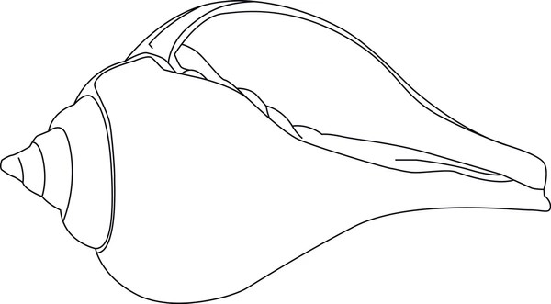 | z
 | if

if
;

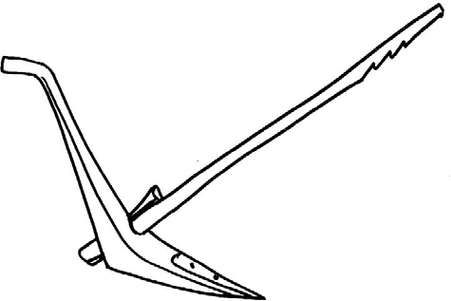 | x
 | If

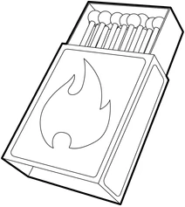 | ;
 | x


%_ ;xL zAbdf uf]nf] 3]/f nufpg'xf];\ M -!)_

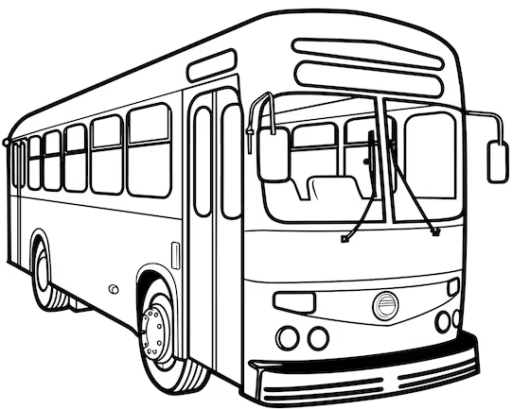
sk | a;

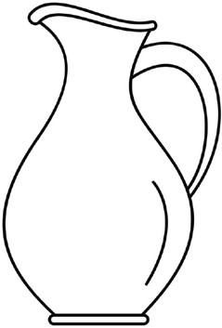
hu | uh

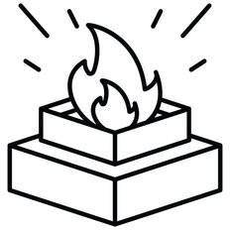
o1 | vn


/y | 3/

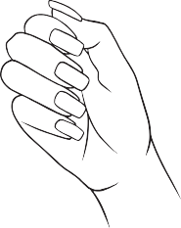
gª | ;/

^_ dgkg]{ lrq agfO{ lrqsf] klxnf] cIf/ n]Vg'xf];\ M -^_

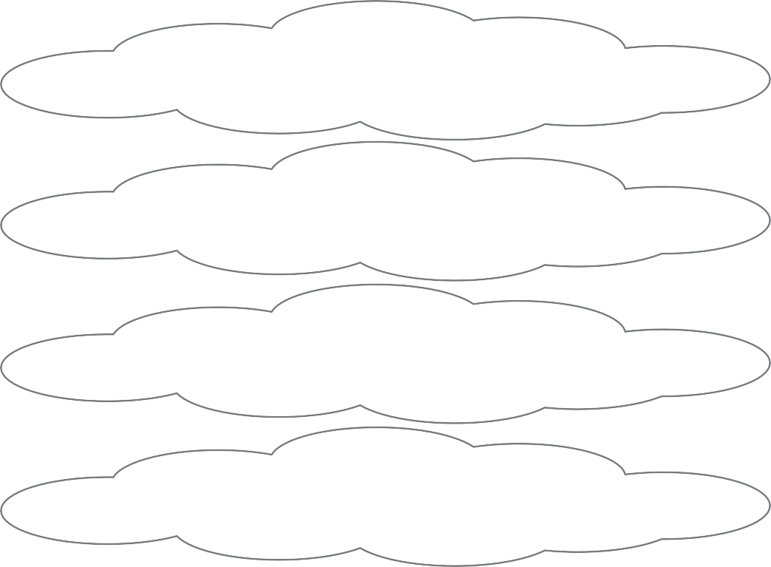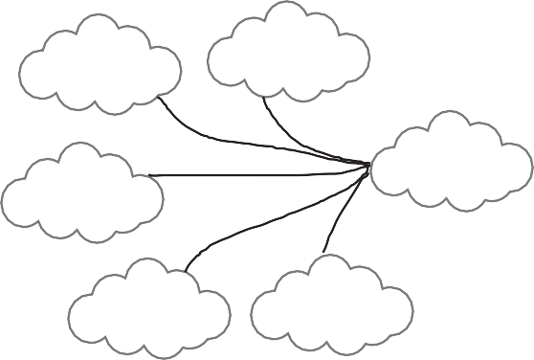
v
u
k
/
;
e
&_ zAb agfpg'xf];\ M -!)_

*_ nofTds zAbdf uf]nf] 3]/f nufpg'xf];\ M -!)_

k;n | au/ | gu/
/a/ | va/ | knª
d6/ | snd | dnd
gx/ | /x/ | dxn
snz | ejg | kjg

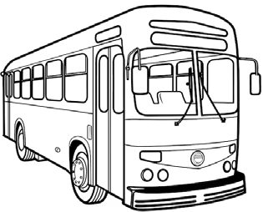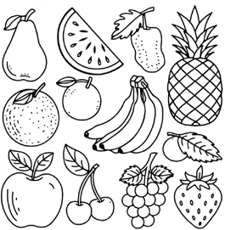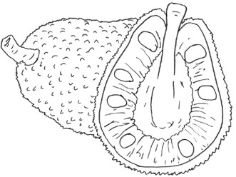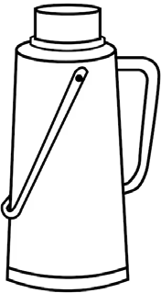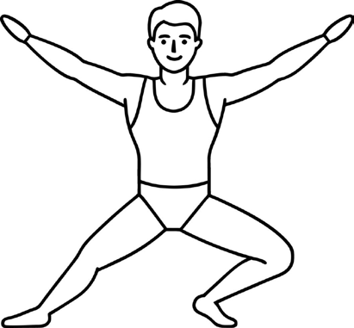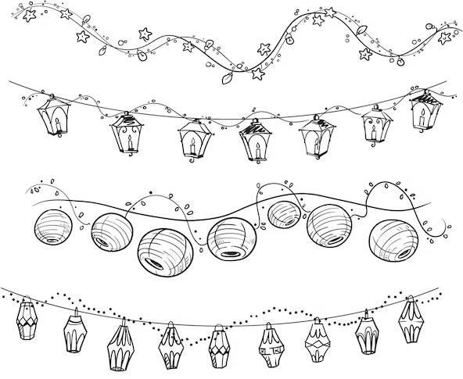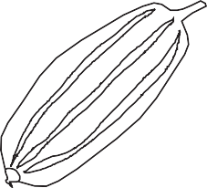
(_ lrq x]/L vfnL 7fpFdf ldNbf] cIf/ n]Vg'xf];\ M -!@_

s – x –
em – d –
y – d –

k – j –
s – / t

!)_ lrq x]/]/ jfSo agfpg'xf];\ M -^_

================================== r9 .

================================== a; .

================================== ug .

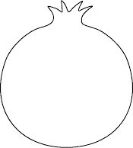
!!_ vfnL 7fpFdf 5'6]sf :j/j0f{x¿ n]Vg'xf];\ M -!)_

c C
cM

!@_ zAbx¿ agfpg'xf];\ M -!@_

b'O{ cgf/n] ag]sf | tLg cgf/n] ag]sf

