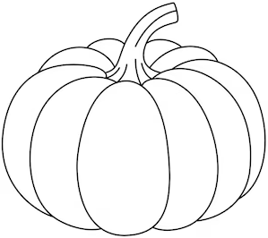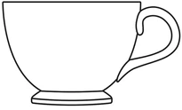First Terminal Examination
Name : Class : UKG
Subject : Mathematics Date :

- In each box colour the biggest as red and smallest as green. (6)

- Number the object from heaviest (1) to lightest (3). (6)

- What comes next? Complete the given pattern. (6)

- Fill in the missing numbers. (8)

4 |  |  | 7

 |  | 17 |  | 19

31 |  |  | 34

 | 46 |  |  | 49
- Fill in the missing numbers. (8)

Before

2
Between

8 10
After

13

10 26

15 31
28 25

33 32

- 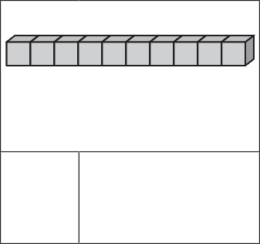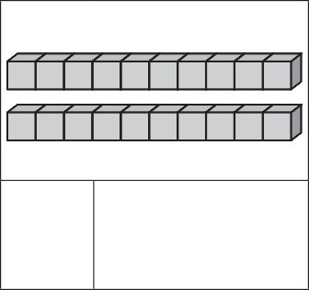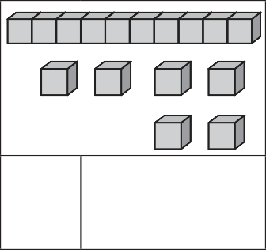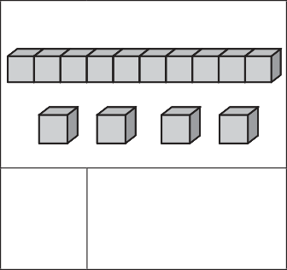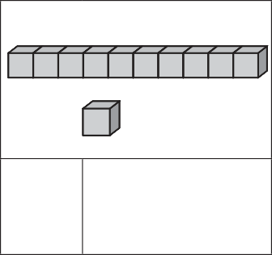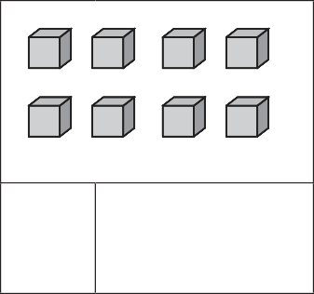Count and write the number and number names. (12)

- Use the symbols greater than (>) less than (<) and equals to (=). (6)

9 7 15 15

20 13 10 17

5 8 19 19

- Write the biggest number in bigger shape and smaller number in smaller shape. (8)

7 8 9

10 15 25
16 13 18

16 9 4

- Match the English number names with Nepali number names. (10)

five six one eight seven

cf7 Ps ;ft kfFr 5

10) Add (+). (10)

+ = + =

+
2
2
+
3
1
+
4
5

- Subtract (–). (10)

– = – =
3
5
2
6

–
4
2
–
3
1
–
6
4

- 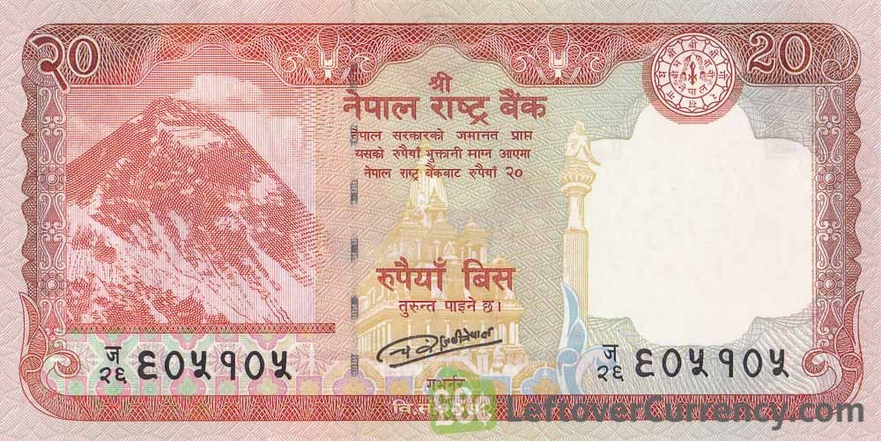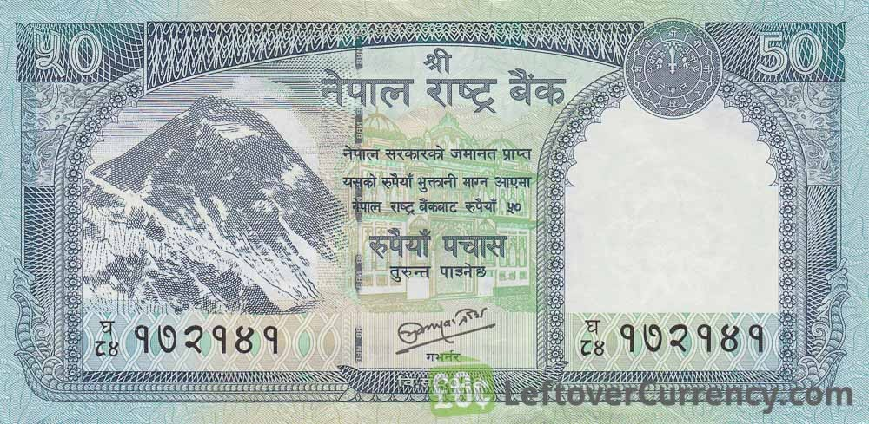Tick (✓) the correct word and colour. (6)

square
circle
triangle
circle

triangle
square

- Recognize the note and write the amount. (3)

