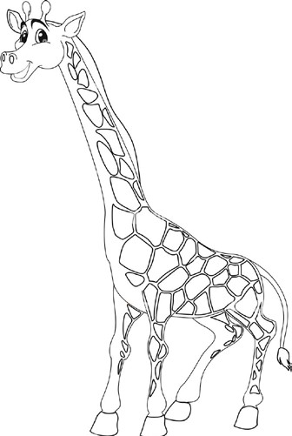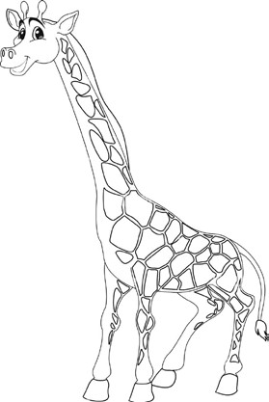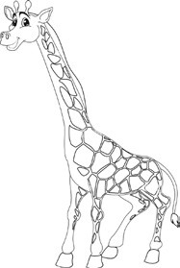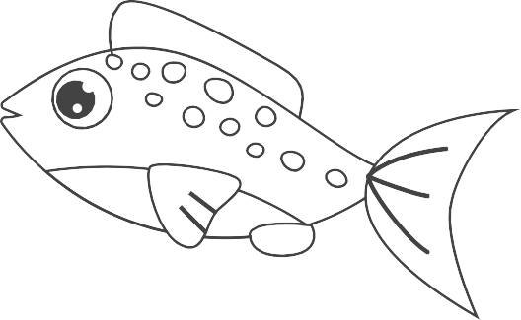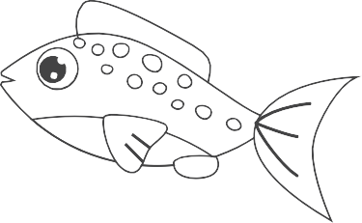First Terminal Examination
Name : Class : LKG
Subject : Mathematics Date :

- Colour the big fish with blue and small fish with red. (10)

- Number the object from taller (1) to shorter (3). (6)

- What comes next? Complete the given pattern. (6)

- Write the missing numbers. (12)

1 4

6 8

12 14

17 20

- What comes? (10)

Before After

2 3

5 Between 6
3 5
7 9
4 6

8 10

- 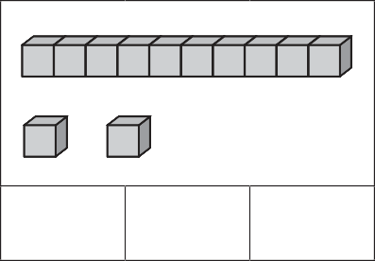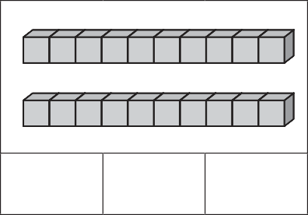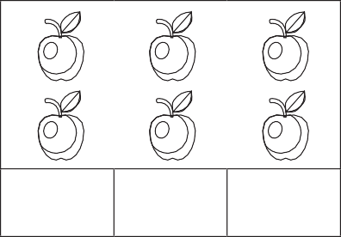Draw the pictures as per the given numbers. (8)

3
8
5
9
- Count and circle the correct number. (10)
3 | 5 | 4

5 | 6 | 7

6 | 7 | 8

10 | 11 | 12

10 | 18 | 20

- 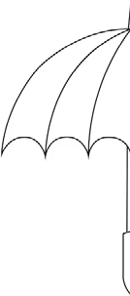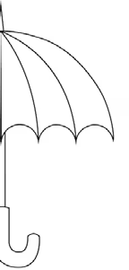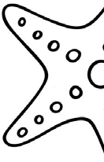Match the objects with their other half. (5)

- Match the English number with Nepali numbers. (5)

15 16 17 18 19

!& !% !( !^ !*

- Write the Nepali numbers from ! to !). (10)

- Count your body parts and write numbers. (8)

I have eyes.  I have nose.  I have ears.  I have fingers. | 

- Join the dots and colour the shapes. (6)

Circle Square

Triangle

- 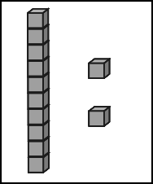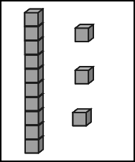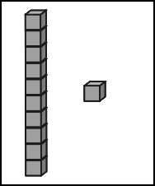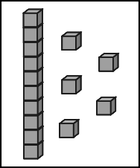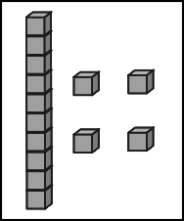Match the numbers with their value and rewrite. (8)

