First Terminal Examination
Name : Class : UKG
Subject : English Date :

- Write the giraffe letters and monkey tail letters. (6)

- Colour the vowel letters blue and consonant letters pink. (13)

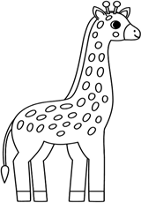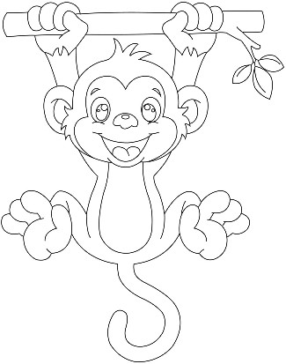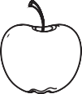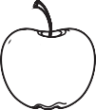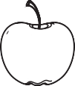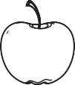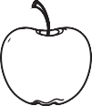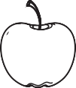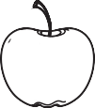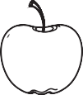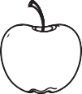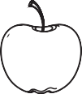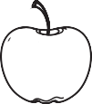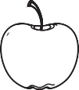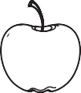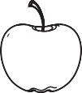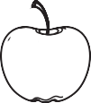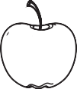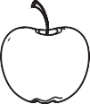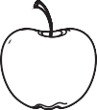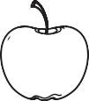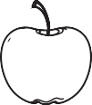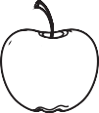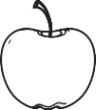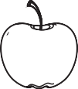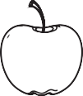b i o

k e r

u d q

z a i

s
n m k

d a g

h v x

u y e

o

- Write down the words beginning with the given letters.(10)
Aa
Cc
Ee
Ff
Gg

- Use ‘a’ or ‘an’ before the words. (6)

.…… apple |  | .…… iron |  | .…… leaf
.…… eraser |  | .…… rabbit |  | .…… orange
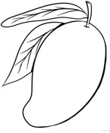
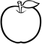
- Make sentences using ‘It’. (8)

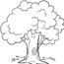



6) Circle the odd one. (5)

dog | drum | elbow | duck
arrow | book | arm | aeroplane
goat | car | candle | cake
grapes | gate | frock | girl
house | hat | hut | balloon

- Look at the pictures and answer in ‘Yes, it is’./‘No, it is not. (8)
  - Is it a mango? 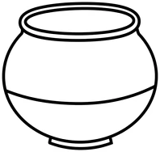

  - Is it a hat? 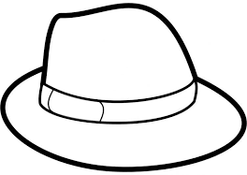
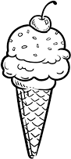
  - Is it a drum? 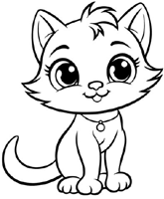

  - Is it an ice-cream?

- Fill the missing letters and complete the words. (5)

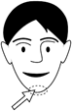
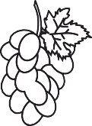
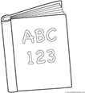
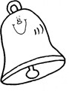
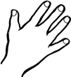
c .… i .…
g .… ap .… s
b .… o .…
b .… l .…
h .… n .…

- Make sentences using ‘This’ or ‘That’. (8)

a)

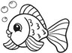
b) 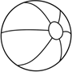
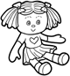
c) 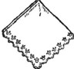

d)

- Match the word with the correct picture. (6)


  - house

  - frock 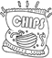
  - girl 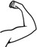
  - bag 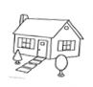
  - arm 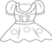
  - chips 
- Write any six sight words. (5)
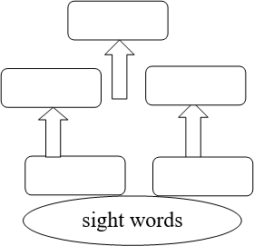

- Write any four polite/magic words. (6)
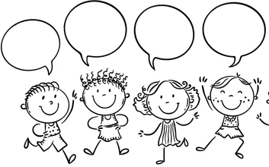
- Draw and color the picture with the given letters. (3)
Aa
Gg
- Fill the gaps using correct pronouns. (He, She, It, I, We). (4)
  - …………….is my father.
  - am good student.
  - …………….is my sister.
  - are good friends.

- Change singular into plural and plural into singular. (5)
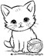
  - a cat
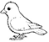
  - three birds

  - a cake 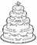

  - two ducks 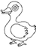

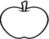
  - an apple


- Colour the picture. (2)
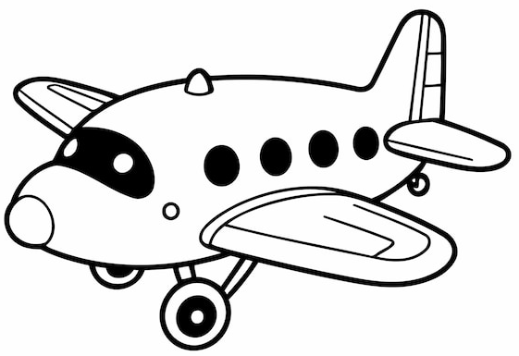
Aeroplane

